
DUY TAN UNIVERSITY
INTERNATIONAL SCHOOL

Software Testing (V&V) – CMU-SE 303 KIS
HOMEWORK
USING KATALON STUDIO TO PERFORM AUTOMATED FUNCTIONAL TESTING ON THE LOGIN TESTING APPLICATION

Version 1.1
Date: Nov 12th, 2026

Created by: Trinh, Nguyen Phuong Kieu
Student ID: 30206249603

Approved by
Sanh, Tran Kim

Elements of Network Security - Mentor:
Name Signature Date
PROJECT INFORMATION
Table 1: Project information
Field | Information
Project acronym | TLTA
Project title | The Login Testing Application
Start date | 1 Nov 2026
End date | 12 Nov 2026
Lead institution | International School, Duy Tan University
Project mentor | Sanh, Tran Kim
Scrum master / project leader and contact | Trinh, Nguyen Phuong Kieu  Email: nguyenpkieutrinh@dtu.edu.vn  Tel: 0853256296  ID: 30206249603
Partner organization | Duy Tan University
Demo link | https://github.com/nguyenphuongkieutrinh/KiemThu.git

Table 2: Revision history
Version | Date | Description
Draft | 1 Nov 2026 | Initial project report and testing plan.
v1.0 | 10 Nov 2026 | Completed testing and result analysis.
v1.1 | 12 Nov 2026 | Standardised layout with automatic table of contents, list of figures and list of tables; aligned test case IDs and results with the Katalon data file; added defect notes and execution setup.
TABLE OF CONTENTS
1. Introduction to the Login Testing Application 1
2. Introduction to Katalon Studio 1
3. Test Design 1
3.1 Equivalence Partitioning 1
3.2 Boundary Value Analysis 1
3.3 Decision Table 1
3.4 Black-box Test Cases 1
3.5 White-box Test Cases 1
4. Test Automation with Katalon Studio 1
4.1 Automation Script 1
4.2 Data-Driven Configuration 1
5. Test Execution and Results 1
5.1 Execution Setup 1
5.2 Summary of Results 1
5.3 Detailed Results 1
6. Defects and Analysis 1
6.1 Failed Test Cases 1
6.2 Defect Report 1
7. Conclusion 1
7.1 Key Lessons and Recommendations 1
7.2 Release Decision 1

LIST OF FIGURES
Figure 1: Login Testing Application user interface 1
Figure 2: Katalon Studio test automation ecosystem 1
Figure 3: Source code of the login() function (practice_login_page.html) 1
Figure 4: Control flow graph of the login() function 1
Figure 5: Groovy automation script for the login test 1
Figure 6: Data binding and Test Suite configuration 1
Figure 7: Katalon execution overview: 30 passed, 4 failed, 0 errors, 0 skipped 1
Figure 8: Execution log for TC_7 (iteration 7): actual "Đăng nhập thành công." against expected "Báo lỗi: Lỗi tài khoản" 1
Figure 9: Execution log for TC_19 (iteration 19): actual "Báo lỗi: Lỗi tài khoản" 1
Figure 10: Execution log for TC_20 (iteration 20): actual "Báo lỗi: Lỗi tài khoản" 1
Figure 11: Execution log for TC_31 (iteration 31): actual message is empty 1

LIST OF TABLES
Table 1: Project information 1
Table 2: Revision history 1
Table 3: Equivalence classes 1
Table 4: Equivalence partitioning test cases 1
Table 5: Boundary value analysis 1
Table 6: Decision table for the authentication logic 1
Table 7: Black-box test case design 1
Table 8: Basis paths of login() 1
Table 9: White-box test case design 1
Table 10: Execution setup 1
Table 11: Test execution summary by technique 1
Table 12: Detailed results of the 34 test cases 1
Table 13: Defect report 1

Introduction to the Login Testing Application
Authentication serves as the frontline defense in software systems, safeguarding user privacy and maintaining system integrity. To explore the intricacies of automated functional testing, this project uses Katalon Studio to design and execute a test suite.
Rather than relying on an existing commercial platform, a custom web authentication system was developed to serve as the System Under Test (SUT). The application has a minimalist interface with a standard login form, which contains "Username" and "Password" fields and a "Login" button (Figure 1).
Because the source code of the SUT is available, the testing team can work in an isolated, controlled environment that closely mirrors real-world QA conditions. The test design combines black-box testing (functional behaviour and boundary conditions) with white-box testing (the conditional logic and input handling of the login function) to find defects in the authentication workflow.
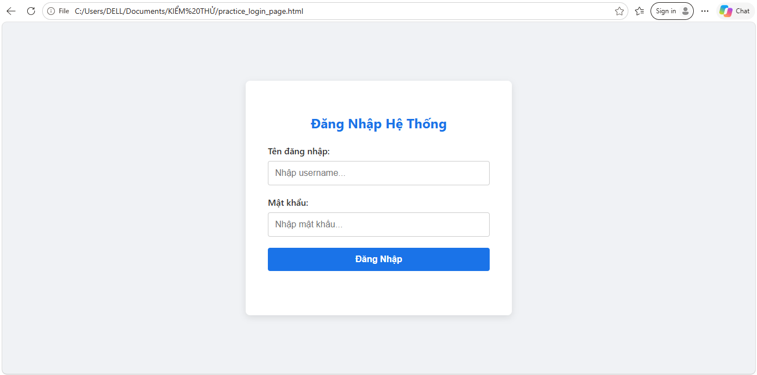
Figure 1: Login Testing Application user interface

Introduction to Katalon Studio
Katalon Studio is an all-in-one automated testing tool that supports Web, API, Mobile and Desktop testing. It is built on the Selenium and Appium engines and provides a graphical user interface, so that the configuration of the underlying frameworks is handled by the tool (Figure 2).
Katalon Studio supports different skill levels. Testers can use "Record & Playback" and built-in keywords to build test cases with a low-code approach. Automation engineers can use Script Mode (Groovy or Java) to write custom validation logic and define test objects.
For functional testing projects, Katalon Studio provides Data-Driven Testing, automated visual reports and integration with CI/CD pipelines. In this project, Data-Driven Testing is used to run one script over a table of 34 test cases.
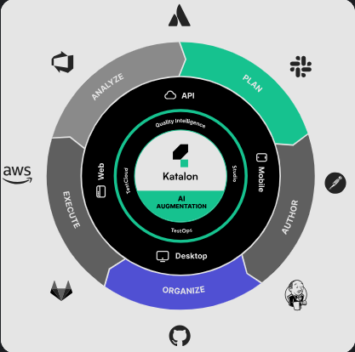
Figure 2: Katalon Studio test automation ecosystem

Test Design

Equivalence Partitioning
Table 3 lists the equivalence classes of the two input fields. Table 4 gives the equivalence partitioning test cases.
Table 3: Equivalence classes
Input condition | Valid class | No. | Invalid class | No.
Username | "student" | 1 | Username other than "student" and "Student" | 3
 |  |  | "Student" | 4
 |  |  | Empty input | 5
Password | "Password123" | 2 | Password other than "Password123" | 6
 |  |  | Empty input | 7

Table 4: Equivalence partitioning test cases
Test case | Covered classes | Test input (username, password) | Expected result
EP01 | 1, 2 | student, Password123 | Login successful
EP02 | 3,2 | admin, Password123 | Error: Invalid Account
EP03 | 4,2 | Student, Password123 | Error: Invalid Account
EP04 | 5,2 | empty, Password123 | Error: Empty input
EP05 | 6,1 | student, Wrong123 | Error: Invalid Password
EP06 | 7,1 | student, empty | Error: Empty input

Boundary Value Analysis
Table 5 shows the boundary values of the username length (limit 20 characters).
Table 5: Boundary value analysis
Boundary condition | Username | Password | Expected result
Minimum − 1 | Empty (0 chars) | Password123 | Error: Empty input
Minimum | s (1 char) | Password123 | Error: Invalid Account
Minimum + 1 | ab (2 chars) | Password123 | Error: Invalid Account
Normal value | student (7 chars) | Password123 | Login successful
Maximum − 1 | 19 chars | Password123 | Error: Invalid Account
Maximum | 20 chars | Password123 | Error: Invalid Account
Maximum + 1 | 21 chars | Password123 | Error: Length exceeded

Decision Table
Table 6 gives the expected behaviour of the authentication logic for each combination of conditions.
Table 6: Decision table for the authentication logic
Condition / action | R1 | R2 | R3 | R4 | R5 | R6 | R7
Exceeds 20 characters | T | F | F | F | F | F | F
Empty input | – | T | F | F | F | F | F
Username = student | – | – | T | T | F | F | F
Password = Password123 | – | – | T | F | T | F | –
Username = Student | – | – | F | F | T | T | F
Display length error | X | – | – | – | – | – | –
Display empty input error | – | X | – | – | – | – | –
Login successful | – | – | X | – | – | – | –
Display password error | – | – | – | X | – | – | –
Display account error | – | – | – | – | X | – | X
Display incorrect login information | – | – | – | – | – | X | –

Black-box Test Cases
Table 7 lists the black-box test cases. Technique codes: EP = equivalence partitioning, BVA = boundary value analysis, EG = error guessing.
Table 7: Black-box test case design
TC ID | Technique | Username / password | Expected result
TC_12 | EP | admin / Password123 | Error: Invalid Account
TC_13 | EP | student / 12345678 | Error: Invalid Password
TC_14 | EP | admin / admin123 | Error: Invalid Account
TC_15 | BVA | s / Password123 | Error: Invalid Account
TC_16 | BVA | student + 250 × 'a' / Password123 | Error: Length exceeded
TC_17 | BVA | student / P | Error: Invalid Password
TC_18 | BVA | student / Password123 + 250 × 'a' | Error: Length exceeded
TC_19 | BVA | " student" / Password123 | Login successfully
TC_20 | BVA | "student " / Password123 | Log in successfully
TC_21 | BVA | student / " Password123" | Error: Invalid Password
TC_22 | BVA | student / "Password123 " | Error: Invalid Password
TC_23 | BVA | "st udent" / Password123 | Error: Invalid Account
TC_24 | EG | st@udent! / Password123 | Error: Invalid Account
TC_25 | EG | student / Pass@word!23 | Error: Invalid Password
TC_26 | EG | stúdènt / Password123 | Error: Invalid Account
TC_27 | EG | ' OR 1=1 -- / Password123 | Error: Invalid Account
TC_28 | EG | student / ' OR '1'='1 | Error: Invalid Password
TC_29 | EG | <script>alert(1)</script> / Password123 | Error: Length exceeded
TC_30 | EG | student / "><img src=x onerror=alert(1)> | Error: Length exceeded
TC_31 | EG | student / Password123[ENTER] | Login successful
TC_32 | EG | student / Password123 | Login successful
TC_33 | EG | student / Password123 | Login successful
TC_34 | EP | student / Password123 | Login successful

White-box Test Cases

Source Code of the Login Function
Figure 3 shows the source code of the login() function. The function checks the input length, then the empty fields, and then the username and password against the expected values.
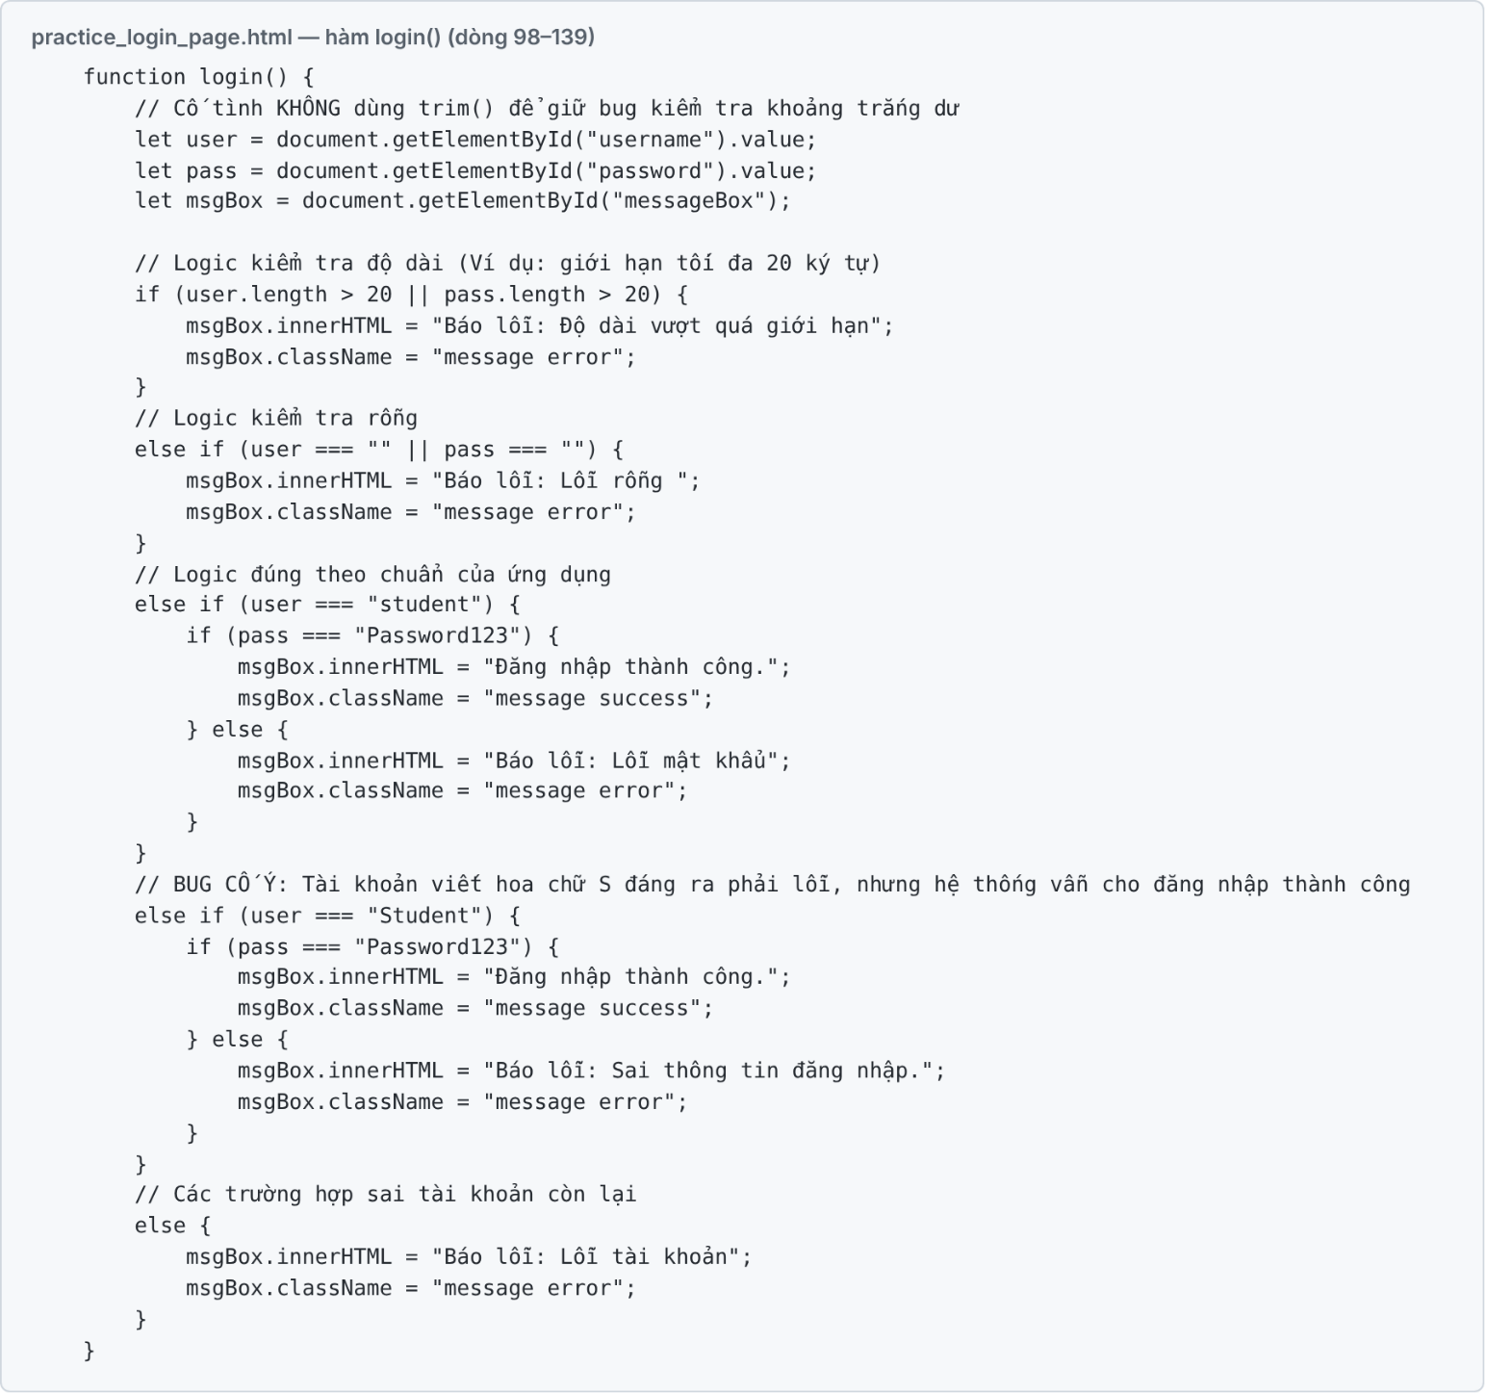
Figure 3: Source code of the login() function (practice_login_page.html)

3.6 Control Flow Graph
Figure 4 shows the control flow graph of login(). Table 8 lists the basis paths BP1 to BP9 by their condition outcomes; the labels are the same as in the Katalon data file. Each basis path is covered by at least one white-box test case (Table 9).
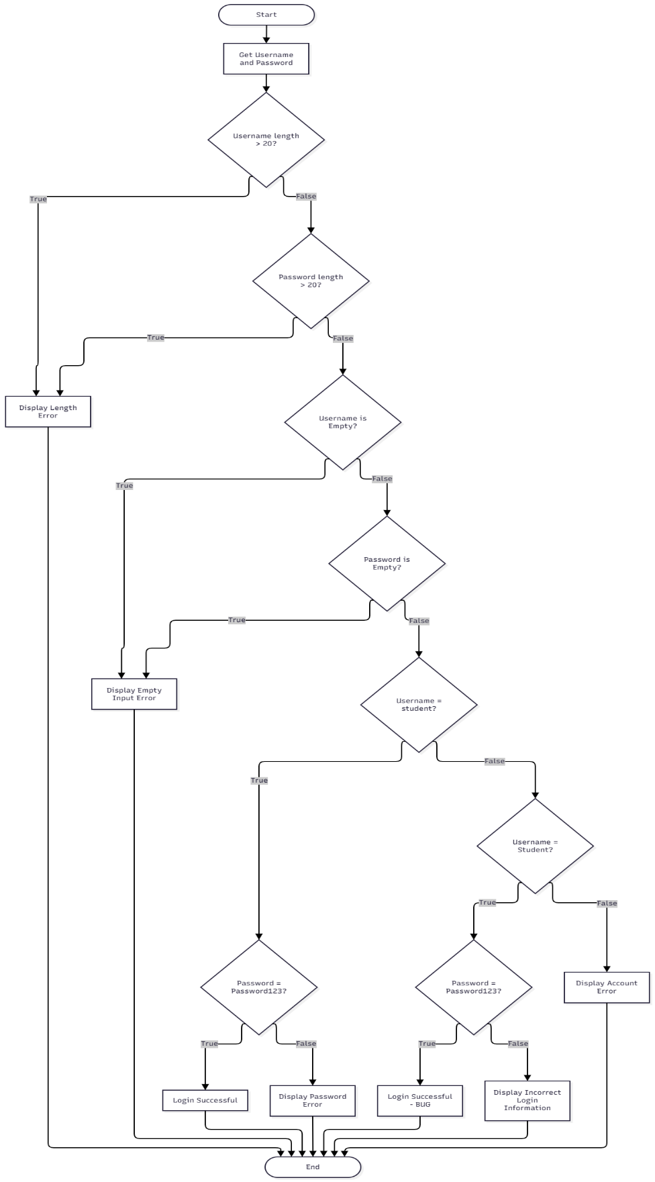
Figure 4: Control flow graph of the login() function
Table 8: Basis paths of login()
Basis path | Condition outcomes | Result | Test case
BP1 | Valid username and password | Login successful | TC_1
BP2 | Username length > 20 | Error: Length exceeded | TC_2
BP3 | Password length > 20 | Error: Length exceeded | TC_3
BP4 | Empty username | Error: Empty input | TC_4
BP5 | Empty password | Error: Empty input | TC_5
BP6 | Username "student", wrong password | Error: Invalid Password | TC_6
BP7 | Username "Student", Password123 | Login successful (defect DEF_01) | TC_7
BP8 | Username "Student", wrong password | Error: Incorrect login information | TC_8
BP9 | Any other username | Error: Invalid Account | TC_9

Table 9: White-box test case design
TC ID | Test case | Username / password | Condition (1st, 2nd) | Expected result
TC_1 | Valid login | student / Password123 | (F, F) | Login successful
TC_2 | Username length > 20 | student + 25 × 'a' / Password123 | (T, F) | Error: Length exceeded
TC_3 | Password length > 20 | student / Password123 + 25 × 'a' | (F, T) | Error: Length exceeded
TC_4 | Empty username | (empty) / Password123 | (T, F) | Error: Empty input
TC_5 | Empty password | student / (empty) | (F, T) | Error: Empty input
TC_6 | Invalid password | student / SaiPass | Statement | Error: Invalid Password
TC_7 | Username case variant | Student / Password123 | Statement | Error: Invalid Account
TC_8 | Case variant, invalid password | Student / SaiPass | Statement | Error: Incorrect login information
TC_9 | Unknown account | SaiUser / Password123 | Statement | Error: Invalid Account
TC_10 | Both fields > 20 characters | student + 25 × 'a' / Password123 + 25 × 'a' | (T, T) | Error: Length exceeded
TC_11 | Both fields empty | (empty) / (empty) | (T, T) | Error: Empty input
For the length check, the pair gives the result of "username length > 20" and "password length > 20". For the empty check, the pair gives the result of "username empty" and "password empty". "Statement" marks test cases that are designed to execute a statement path rather than a pair of conditions.

Test Automation with Katalon Studio

Automation Script
A single Groovy script runs all 34 test cases (Figure 5). For each data row, the script opens the browser, opens practice_login_page.html, sets the username and the password, clicks Login and waits for the message. It then compares the message with the expected result and records PASS or FAIL. A mismatch does not stop the run (verifyMatch with CONTINUE_ON_FAILURE).
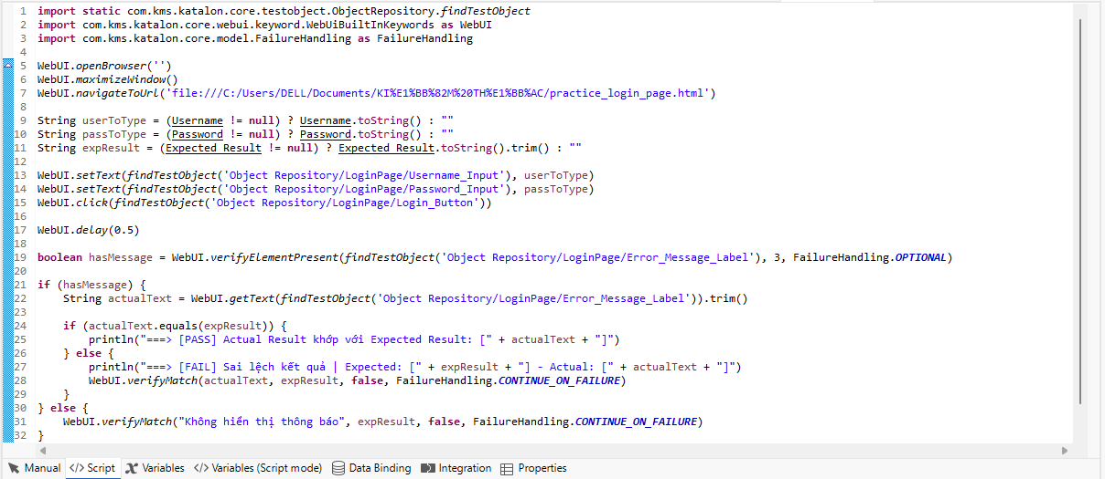
Figure 5: Groovy automation script for the login test

Data-Driven Configuration
The test data are stored in an external data file with the columns Test Case ID, Username, Password, Expected_Result, Status and Technique. The data are bound at Test Suite level (Figure 6).
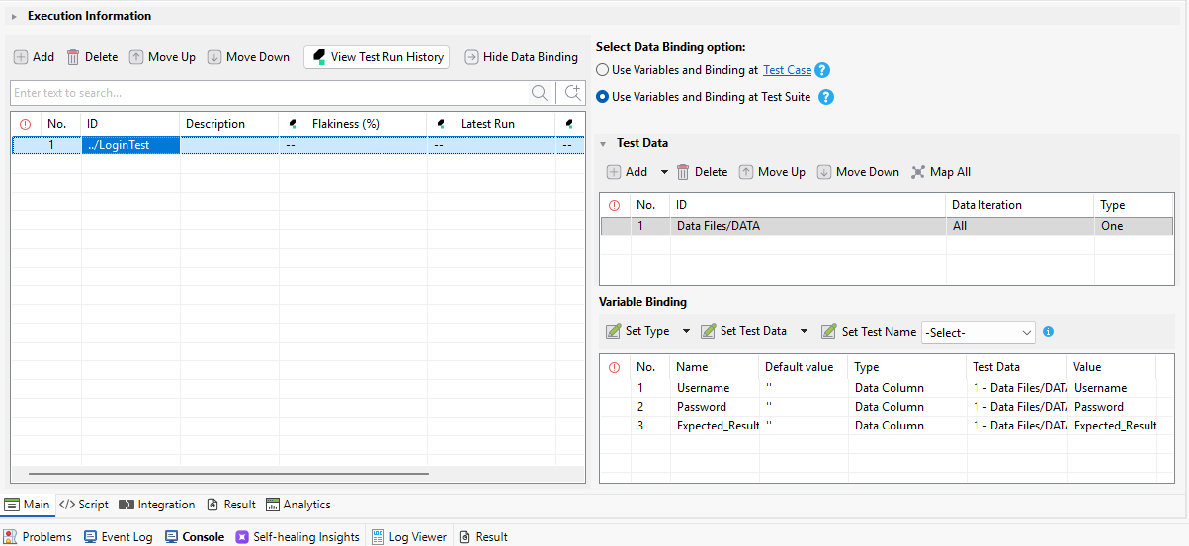
Figure 6: Data binding and Test Suite configuration

Test Execution and Results

Execution Setup
Table 10: Execution setup
Item | Detail
Test tool | Katalon Studio (Groovy script mode, data-driven testing)
System under test | practice_login_page.html (local file)
Test data | External data file, 34 rows (TC_1 to TC_34)
Execution date | 12 Nov 2026, 18:27–18:28
Retry policy | A failing iteration is retried up to 3 times. All four failures failed on the first run and on all three retries.

Summary of Results
Of the 34 test cases, 30 passed and 4 failed (Table 11). No test case had an error or was skipped. Figure 7 shows the execution overview of the run.
Table 11: Test execution summary by technique
Technique | Test cases | PASS | FAIL | Pass rate
White-box: statement, basis path, condition (TC_1 – TC_11) | 11 | 10 | 1 | 90.91%
Black-box: equivalence partitioning (EP) | 4 | 4 | 0 | 100.00%
Black-box: boundary value analysis (BVA) | 9 | 7 | 2 | 77.78%
Black-box: error guessing (EG) | 10 | 9 | 1 | 90.00%
Total | 34 | 30 | 4 | 88.24%

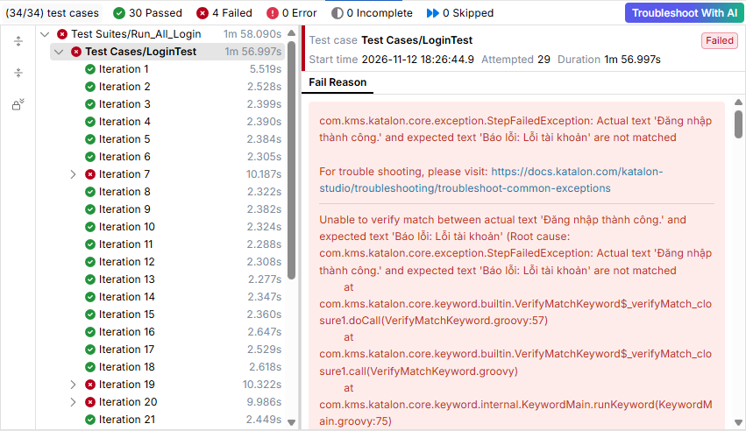
Figure 7: Katalon execution overview: 30 passed, 4 failed, 0 errors, 0 skipped

Detailed Results
Table 12: Detailed results of the 34 test cases
TC ID | Technique | Status
TC_1 | WB | PASS
TC_2 | WB | PASS
TC_3 | WB | PASS
TC_4 | WB | PASS
TC_5 | WB | PASS
TC_6 | WB | PASS
TC_7 | WB | FAIL
TC_8 | WB | PASS
TC_9 | WB | PASS
TC_10 | WB | PASS
TC_11 | WB | PASS
TC_12 | EP | PASS
TC_13 | EP | PASS
TC_14 | EP | PASS
TC_15 | BVA | PASS
TC_16 | BVA | PASS
TC_17 | BVA | PASS
TC_18 | BVA | PASS
TC_19 | BVA | FAIL
TC_20 | BVA | FAIL
TC_21 | BVA | PASS
TC_22 | BVA | PASS
TC_23 | BVA | PASS
TC_24 | EG | PASS
TC_25 | EG | PASS
TC_26 | EG | PASS
TC_27 | EG | PASS
TC_28 | EG | PASS
TC_29 | EG | PASS
TC_30 | EG | PASS
TC_31 | EG | FAIL
TC_32 | EG | PASS
TC_33 | EG | PASS
TC_34 | EP | PASS

Defects and Analysis

Failed Test Cases
Four test cases failed. Figure 8 to Figure 11 show the execution logs of the failed iterations.
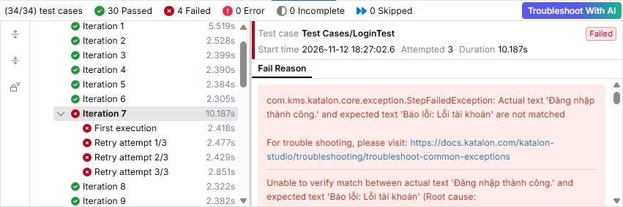
Figure 8: Execution log for TC_7 (iteration 7): actual "Đăng nhập thành công." against expected "Báo lỗi: Lỗi tài khoản"
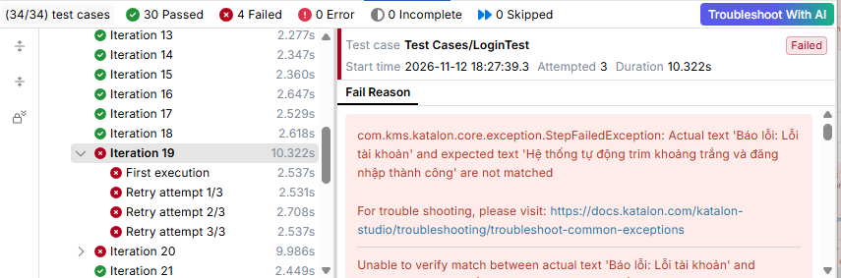
Figure 9: Execution log for TC_19 (iteration 19): actual "Báo lỗi: Lỗi tài khoản"
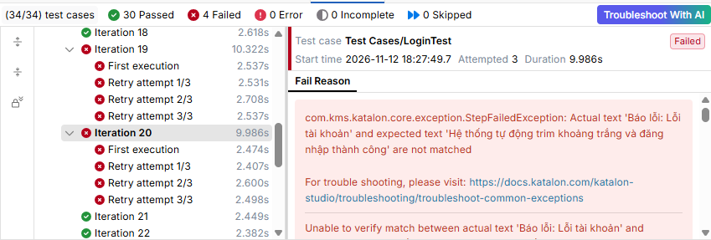
Figure 10: Execution log for TC_20 (iteration 20): actual "Báo lỗi: Lỗi tài khoản"
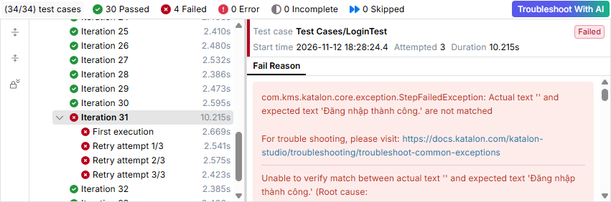
Figure 11: Execution log for TC_31 (iteration 31): actual message is empty

Defect Report
Table 13: Defect report
Defect ID | TC ID | Description | Expected result | Actual result | Severity
DEF_01 | TC_7 (EP03) | Username "Student" with the correct password is accepted. | Error: Invalid Account | Login successful | High
DEF_02 | TC_19 | Leading space in the username is not trimmed. | Trim whitespace and log in successfully | Error: Invalid Account | Medium
DEF_03 | TC_20 | Trailing space in the username is not trimmed. | Trim whitespace and log in successfully | Error: Invalid Account | Medium
DEF_04 | TC_31 | The Enter key does not submit the login form. | Login successful | No message is displayed | Low

Conclusion
The test suite executed 34 test cases using Katalon Studio with data-driven testing. Of these, 30 passed and 4 failed, giving a pass rate of 88.24%. The application handles standard logins, empty input, over-length input and unknown accounts correctly. The failures show that the application accepts a username with a different letter case ("Student"), does not trim leading or trailing spaces in the username, and does not submit the form with the Enter key.

Key Lessons and Recommendations
- Input normalisation and strict validation: client-side input must be trimmed (for example with .trim()), and the username comparison must follow one documented rule (for example, case-sensitive) to avoid inconsistent access.
- Keyboard accessibility: the form should respond to the Enter key as well as to a mouse click.
- Automation: combining white-box analysis with black-box data-driven automation in Katalon Studio isolated the edge-case defects quickly and gave a reusable regression suite for future builds.

Release Decision
The application is not ready for production release in its current state. The team should fix DEF_01 (High), then DEF_02 to DEF_04, and run a full regression test before the final release.

